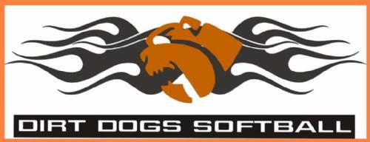
Dirtdogs Athletics, 14U Girls Softball
Tax ID Number: 83-1007749
Dear Sir/Ma'am:
We are a competitive Junior Olympic Travel “A” softball program for female athletes. Our priorities and goals are education, player development, and individual growth through the dynamic and invaluable experiences obtained through elite softball competition. We travel throughout California and beyond to compete against the finest travel softball organizations/teams in the state and country. We are asking you to sponsor us, and help with the cost of uniforms, equipment and travel expenses for the 2021 season. Your support and sponsorship will have a tremendous impact on our upcoming season. Your assistance will provide the necessary support to allow our team to ensure a successful season. All money donated goes directly to our athletes.
Again, thank you in advance for your support. Keep a copy of this form as your receipt. If you have any questions, please contact me at (559) 999-6671.
Bryan Close
Dirtdogs 14U Coach

Mail to:

Central Cal Dirtdogs 10U
c/o Bryan Close
21445 S. Christina Ct.
Riverdale, Ca. 93656

Player: ___________________________________ Amount: ________________

Please complete the following information (Keep a copy as your receipt)

Individual/Business/Organization Name: __________________________

Address: ___________________________________________________

Contact Person: ________________________ Phone #: _____________

