Glitter It Up!
714.397.8164
glitteritup@sbcglobal.net

#1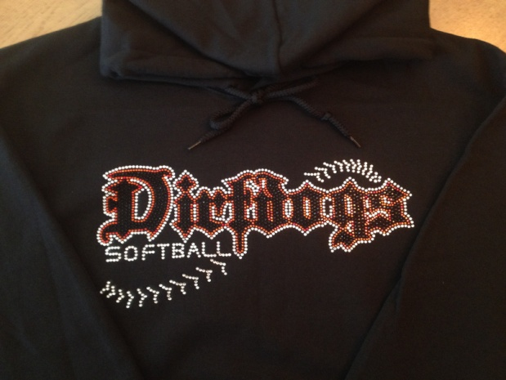 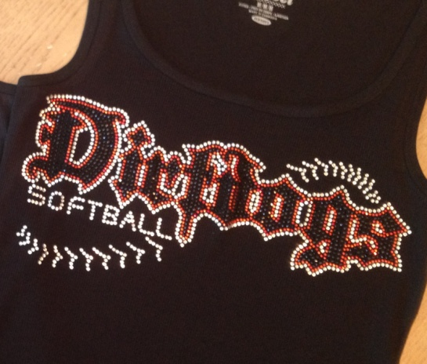 #2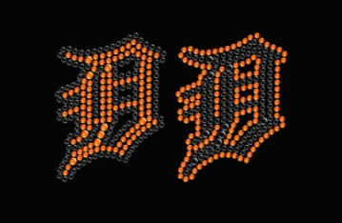
(For Hats)

Name:______________________________________________________________________________
Phone:____________________ Address:___________________________________________
City/Zip:___________________________________________
Credit Card#_____________________________________________________ Exp:______________
Sec. Code On Back of Card:_________________Billing Zip:____________________________
Design # | Item # | Size | Color  Of Top | Name on front (1"Letters) $3 | Name on Back (2.5" Letters)$8 | Price
Total:______________
Thank You!
Like us on Facebook @ www.facebook.com/GlitterItUp
Make checks payable to Glitter It Up!
Don't forget to order your Custom Blinged Stadium Chair!!! $60

Glitter It Up!
Item Options:
#1$40 #2 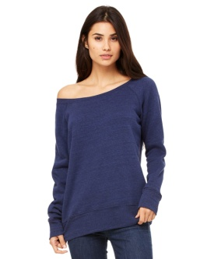$34
(Black or White) (White or Black)
#3 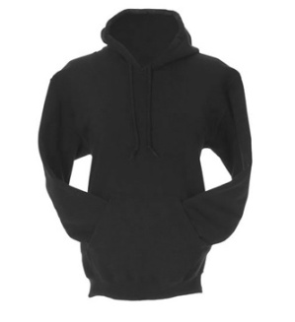$40 #4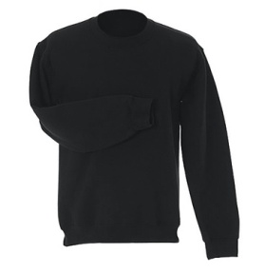$28 #5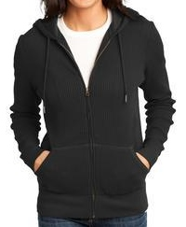$42
(Sweatshirts available in Black or White)
#6 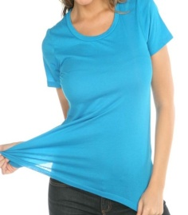$28 #7 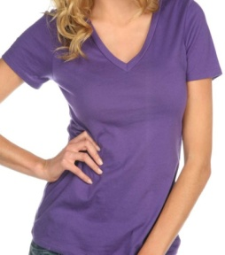 $28 #8 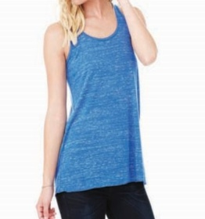$25
(Black White) (Black or White) (White or Black)
These available in long sleeve, too!!!! $30
#9 $25 #10 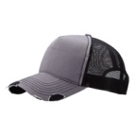$22
(Black or White) Blinged Ball Caps
(Grey/Black, Black or White) STCH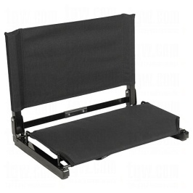$60

Glitter It Up!
Additional designs:
#2 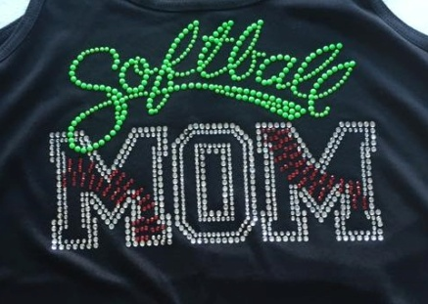 #3 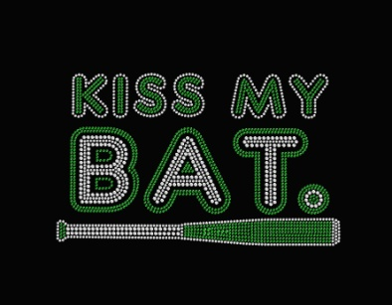
#4 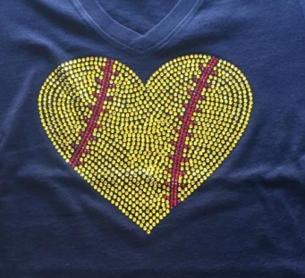 #5 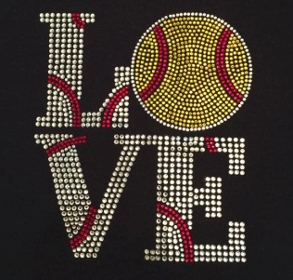
#6 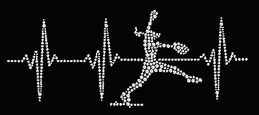
#7 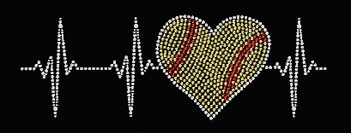
All designs will be color specific for your team!

